Linux
OS is simply a collection of softwares that manages hardware resources and provide a enviorment where applications can run.
Linux is a kernel. It represent the kernel as linux or heart of the OS. It is the layer that sit between hardware and applications.
Created by linus torvals in 1991 or early 90’s.
Linus is foss. The source code is free, but in some case the distribution is not free, the binary the compile code is not free. You need to have license to run Red hat enterprise linux. However red hat releases its source code for any1 to download.
Linux distributions
For commercial distribution of linux you have, customer support.
There are linux distribution that is designed for server used.
Others are defined for desktop use.
Some are focused on research and science.
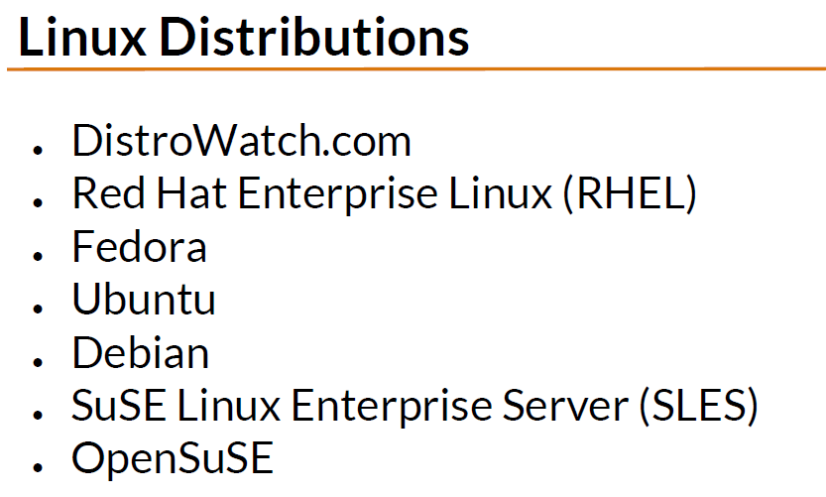

Linux runs on dedicated network devices to all. Proprietaty Unix OS only runs on the hardware of their company. For e.g hp UX only runs on hp servers. AI x only runs on ibm server. Linux can run on hp and ibm server.
Linux was developed on pc hardware on intel processors.
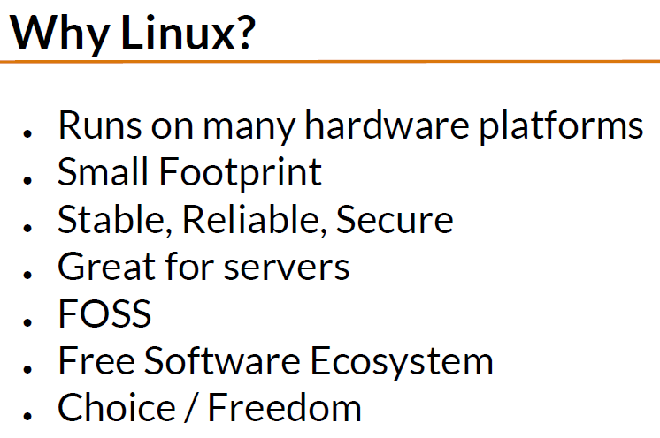

Small footprint allows linux to run on older os or un embedded systems.
Having a commercial linux distribution for your server might be good, cuz u’ll get customer support.
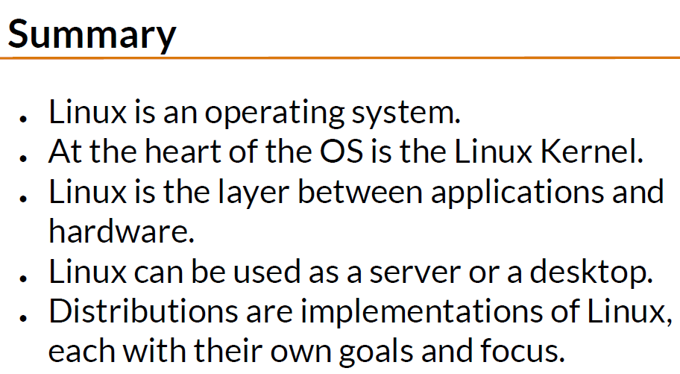

Linux Distributions
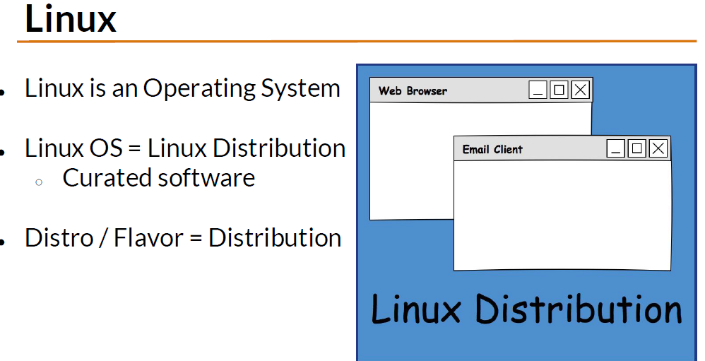

Linux distribution is collection of software and application bundle together and distributed as a single OS.
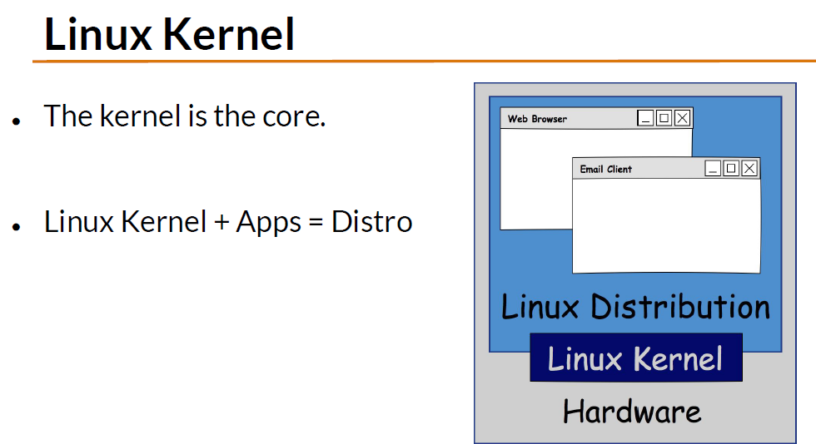

Most popular linux are redhat and ubuntu.
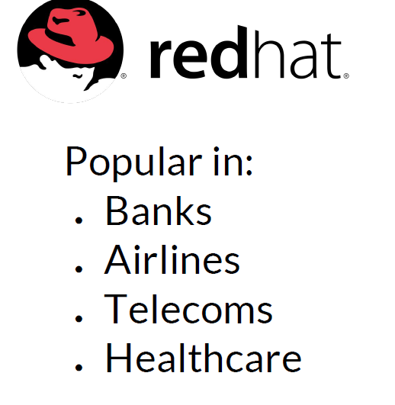
Use CentOS which is redhat derivative and its completely free.

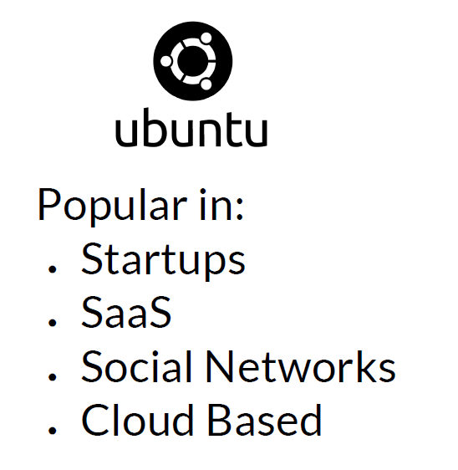

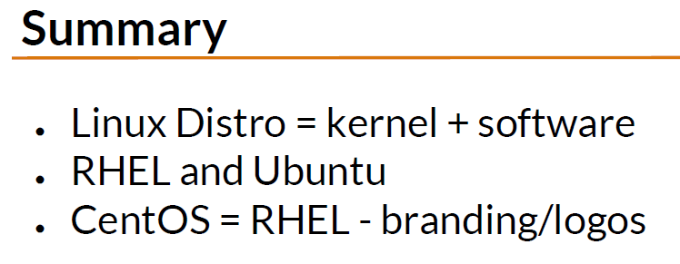

Linux directory structure
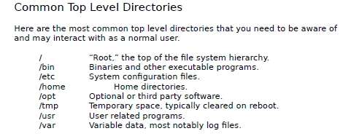

Configuration files controls how OS or application behave. There is a configuration file in /etc that tells the OS to boot into text mode or Graphical mode.
You can have multiple users in a linux os, /home seperates your data with another user data.
/opt where third party software, for e.g google earth isnt bundled with linux os.
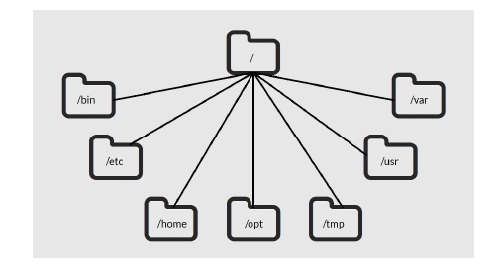

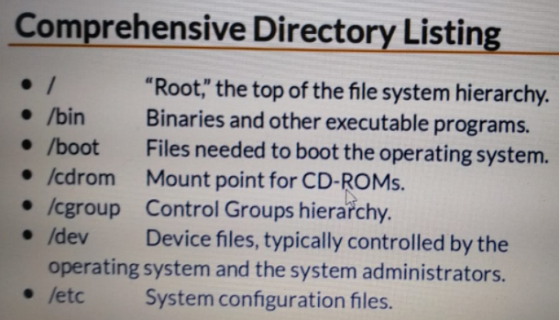

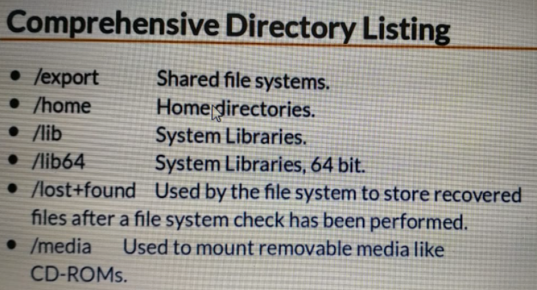

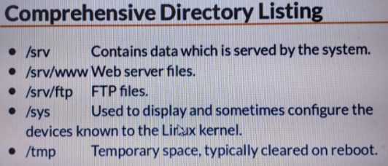

Some linux os use /srv as a location to place data that is served by the linux server.

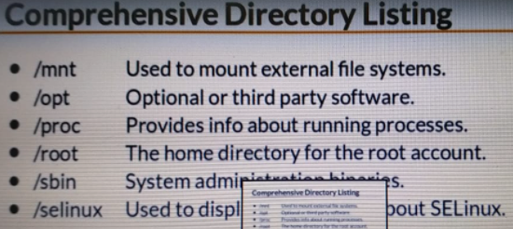

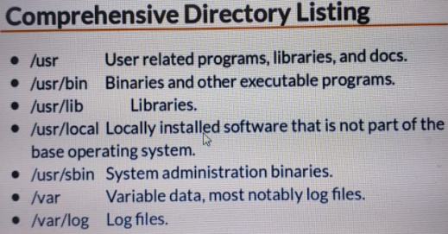

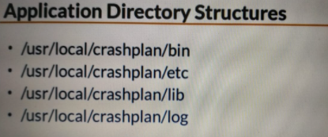
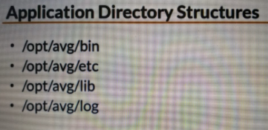
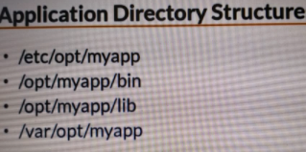
Some applications that are not bundled with linux OS are stored in usr/local. Crashplan is backup software. If u wanna modify how the program is behave during Runtime you will modify usr/local/crashplan/etc
opt is optional or third party software.

Consider this fictious program myapp. Here even though the main program get installed at opt/myapp where its bin,lib resides. You can find config files at /etc /opt /myapp and log files at /var /opt /myapp.
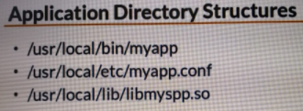
Sometimes when application is installed they are not given their directory structure they are installed in a shared manner.

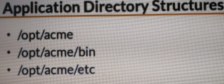
So if you work for acme corporation and you logged in one of their linux
servers , you will see

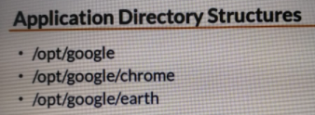

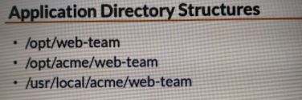

Applications which are not shipped with linux OS, they are typically found in opt or usr / local.

The Shell
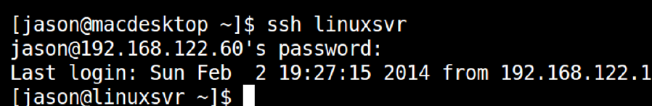
The shell is the default user interface to the linux os.
When you login to linux server over the network, the shell is the program that is started and which interacts your default interface to the system.
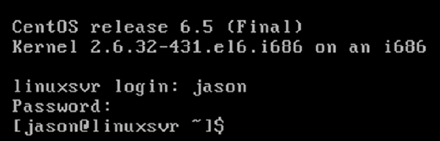

If you r presented with text based login prompt you also maybe interacting with shell by default.
If you login to a graphical user interface, then you need to start terminal emulator application to gain access to the shell.
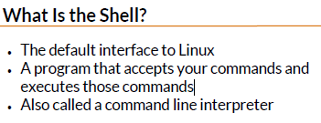

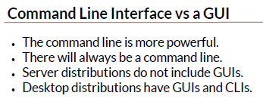

if you connecting over to a linux computer over the network, you typically being connected via SSH. This will give u access to CLI.

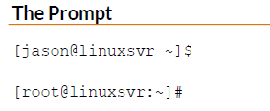
Username @ name of the linux system you connected to.

The $ tells you r a normal user, not a super user.
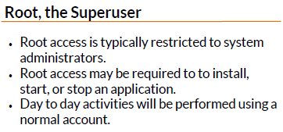
Application that runs services or server typically require root access to start.

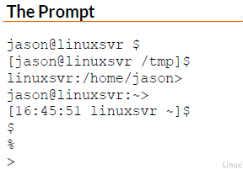
~ is used to represent the home directory.

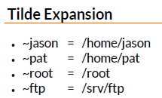

Not all accounts on a linux system are associated with an individual user. For e.g services often have their own accounts.
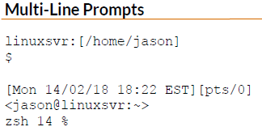
~ftp expand to the home directory of the ftp service account.

Basic linux commands
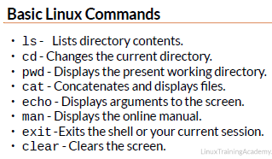
echo $PATH
its used to display the contents of the variables. We will use env var later on.

Teach yourself to fish
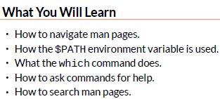
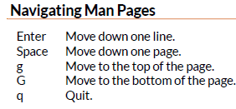

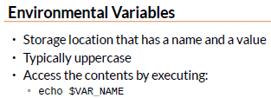

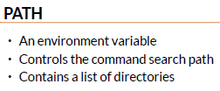
So if you typed a command that cmd will be search on Path which contains list of directories seperated by Colon.
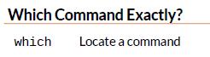
it gives the directory where the command is.
For e.g
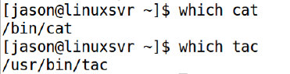
tac cmd shows the file content in reverse order.

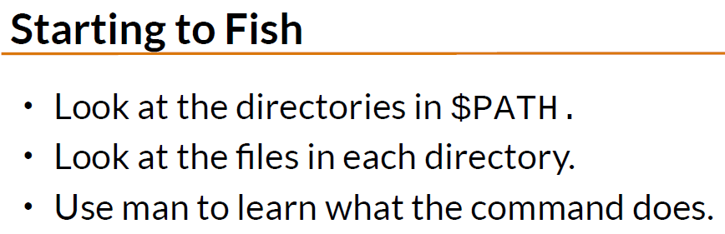

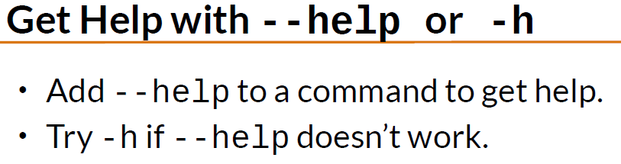



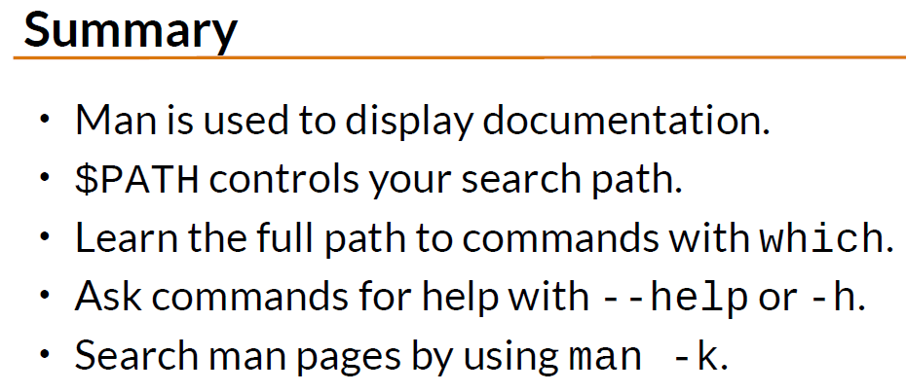

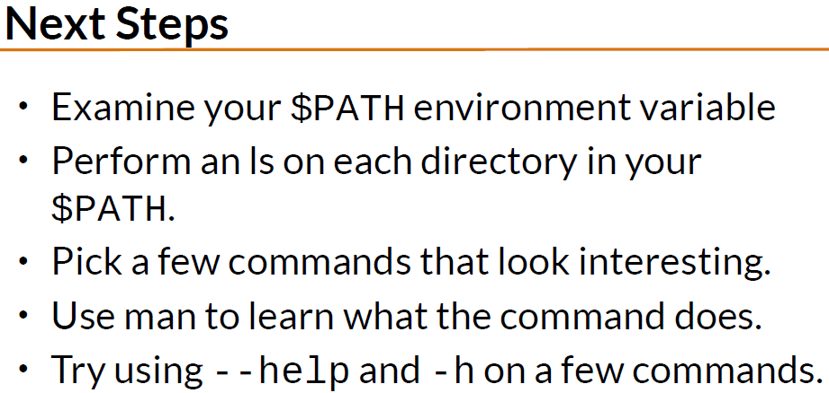

Working with Directories
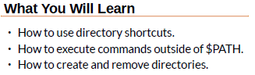

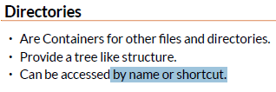

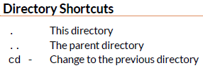
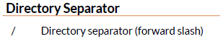

echo $OLDPWD
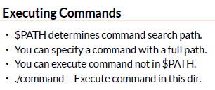

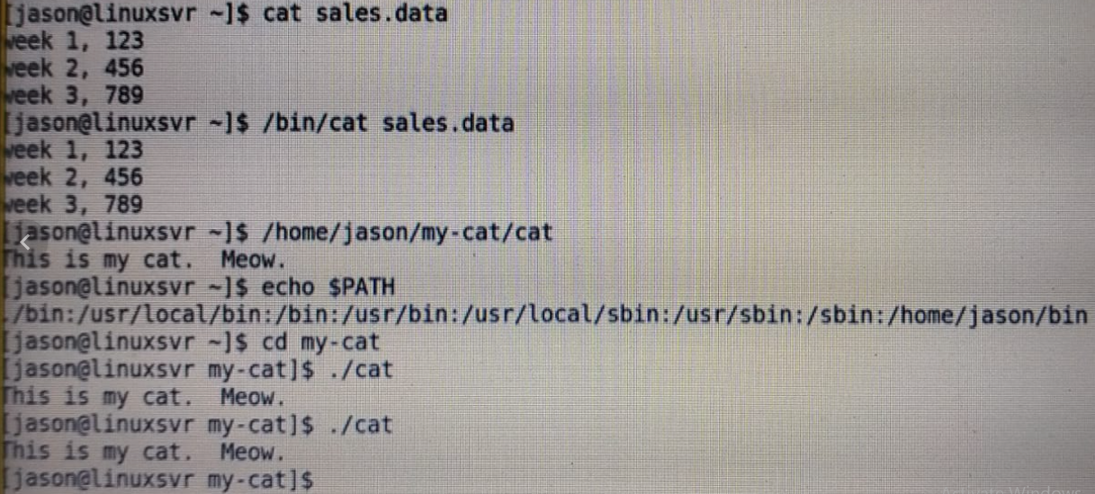

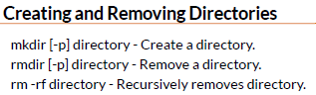

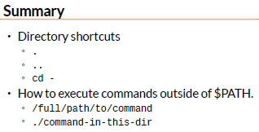

Listing files and understand LS output
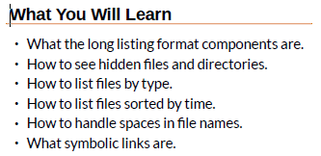
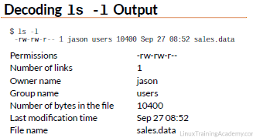

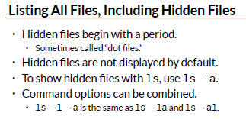

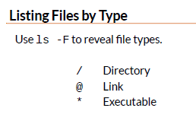

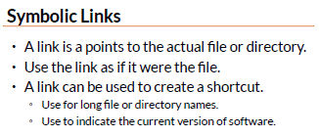

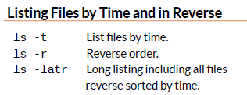

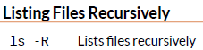

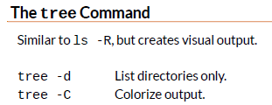

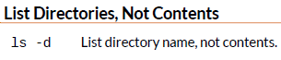

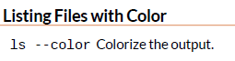

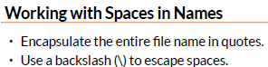

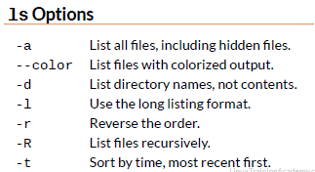

Day 3

File and Directory permission explained
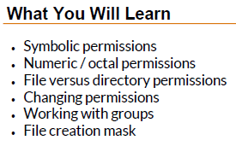

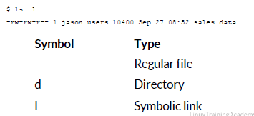

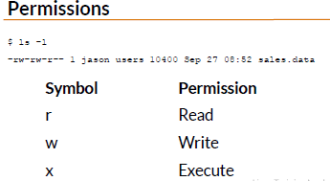

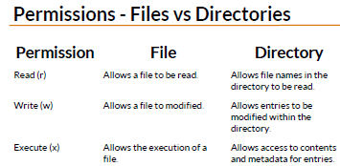
Read for directory gives you the ability to see file name, whereas write permission in directory gives the ability to see metadata, modification date, time stamp owner and group information.
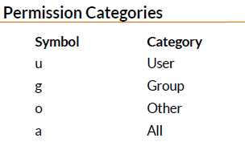
U Represent the user who owns the file. The user in the file group are represented by g.

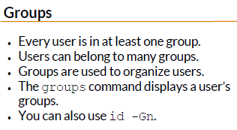

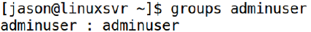

If the member of the sales team, need to be have access to some of the same files and directory, they can be place in sales group.
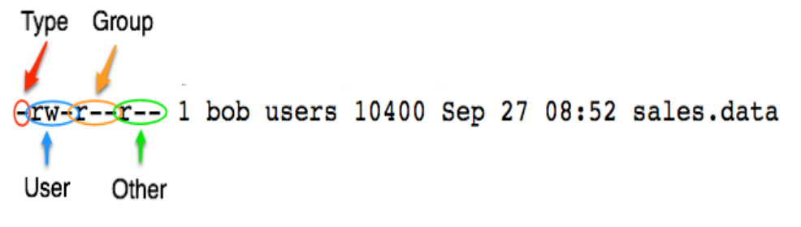

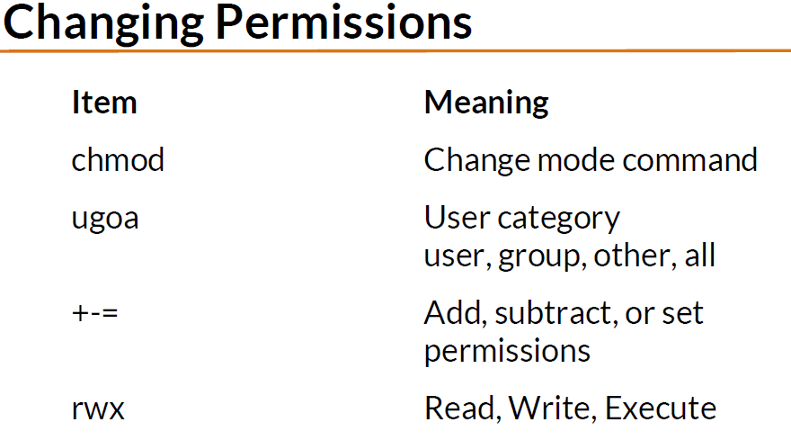

chmod g+wx sales.data
chmod a=rwx sales.data
chmod u=rwx,g=wx,o= sales.data ← permission for others is none now
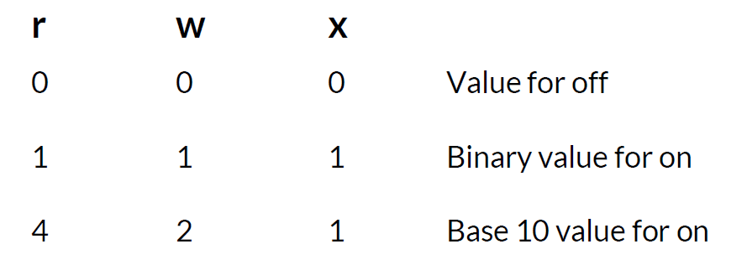

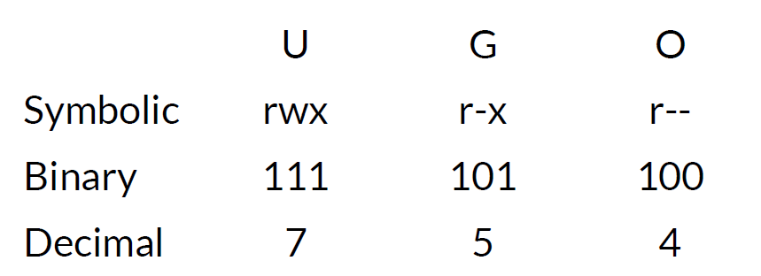

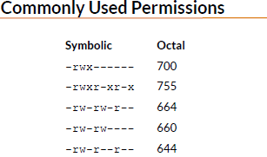

Dont use 777, so if malicious code is inserted by a person, it would cause trouble.
If multiple ppl need access to a file, consider using groups.
Avoid using 777,666

File and Directory permission explained part two
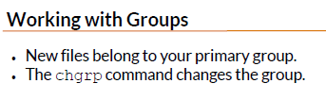

if you r member of multiple group for e.g sales, training group. If sales is ur primary group. When you create a new file, it would be in sales.group.
$groups
$chgrp sales sales.data
Instead of keeping files in different people home directories. Maybe you can have a common place to store it.
$ls -ld / usr / local/ sales
$mv sales.data / usr / local/ sales
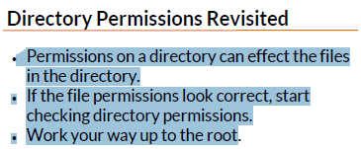

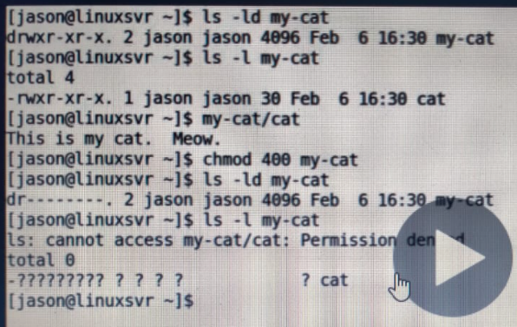
So here you have the permission to read the files, but u cant. Cuz u don’t have the directory permission to read its contents .

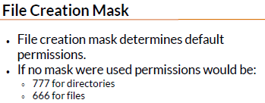

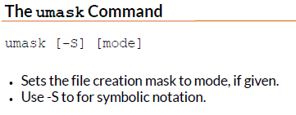

The mode given to umask works in opposite way of working in chmod.
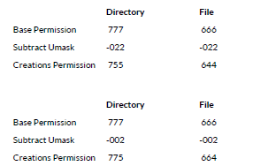
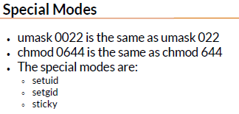

View files and the nano editor
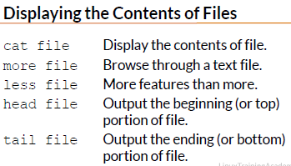
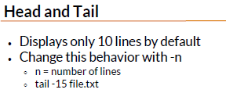

Cat command are used to read files that have static content.
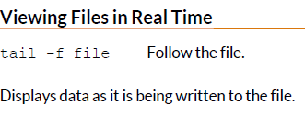

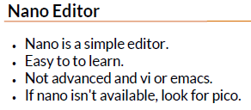
Ctrl-d for help.
Ctrl- o to save

Editing files in Vi
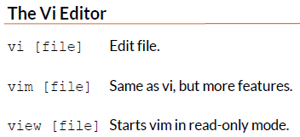
Vim means vi improved.

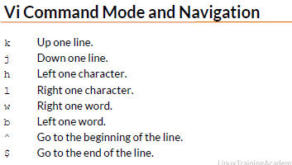

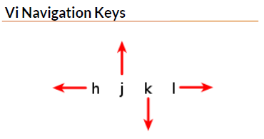

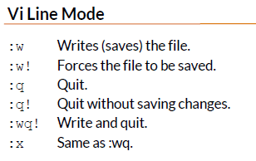
In order to insert text in a file.
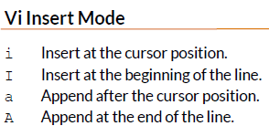

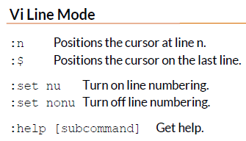

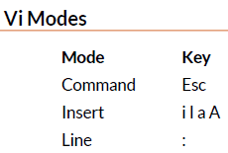

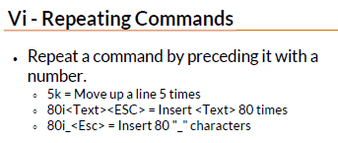

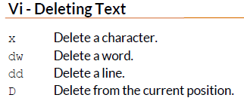

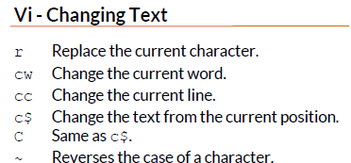
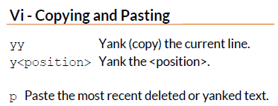

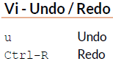

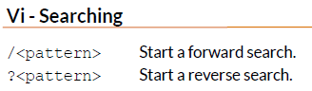

Finding files and directories
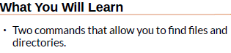

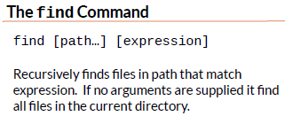

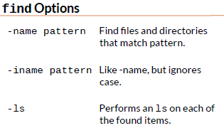
find [path..] -name pattern

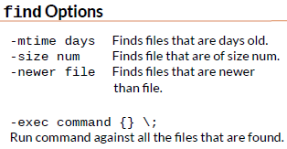
-mtime +10 -mtime -13
find . -size +1M

find . -type d -newer file.txt
find -exec file {} \;
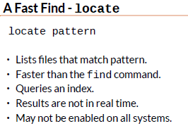

Graphical editors
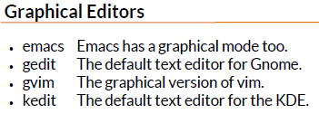



Day 5

Deleting, copying, moving and renaming files
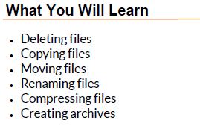
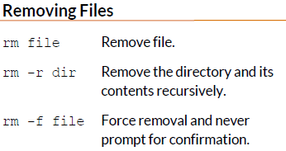

Search pattern can be used to delete multiple files at once.
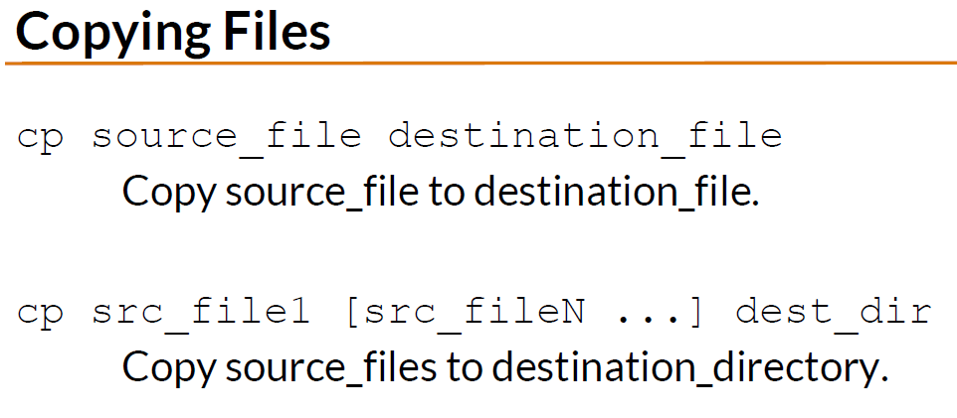

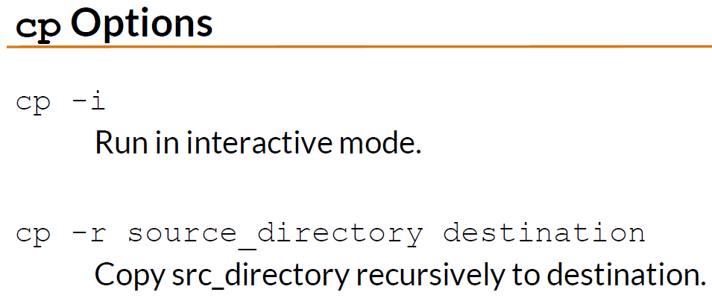

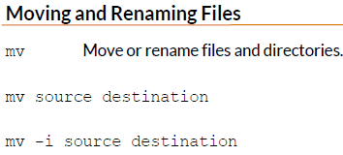

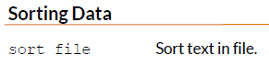

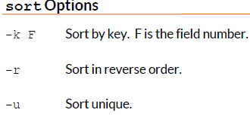

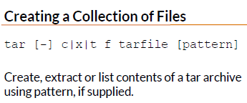

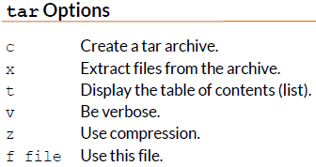

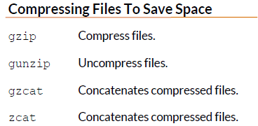

To view the contents of zip archive use gzcat.

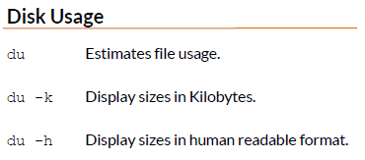

Wildcards
Wildcards can be used with ls,rm,cp .
ca[nt]*
[] outputs exactly one character.
Can
cat
candy
catch
[!aeiou]
[a-g]* ← start with characters from a-g
[3-6]* ← start with numbers from 3to 6
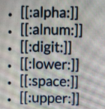
escape characters?
*\?
>>> done?

WildCard Part 2
Ls *[[:digit:]]
Whenever u deleting stuff, test ur wildcard pattern using the ls command.
This way u don’t delete any file that you don’t intend to remove.

Input, Output, and Redirection
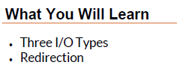
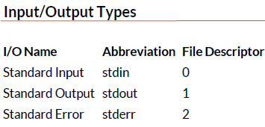

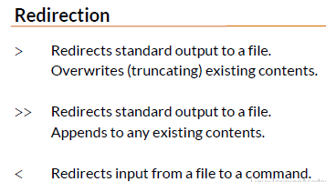

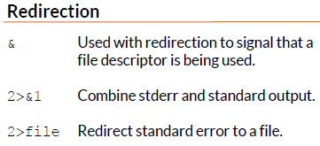

Redirection can be used to redirect the output as input for another chain command or save it in a file or not show th error.
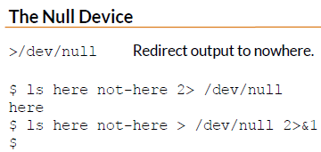

Note:
> Redirection
what this does it redirect the stdout to a file or to a command.
>> Redirection + append
2>&1
since error always get shown, you can make Stderr as Stdin.
2>/dev/null
Its a bit bucket for errors.

Comparing files
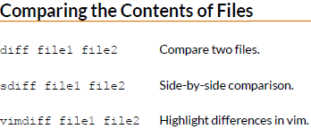

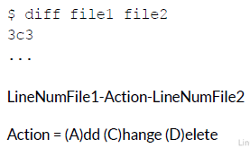

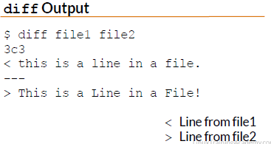

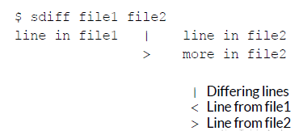

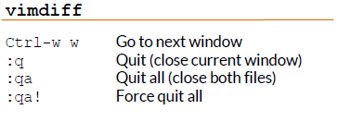

Searching in files and Using Pipes
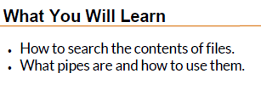

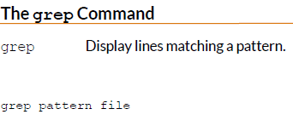

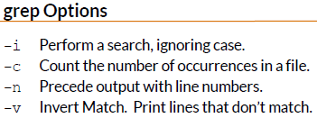

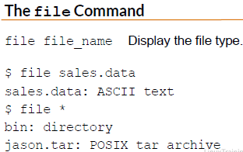

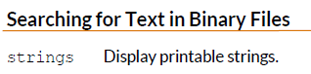

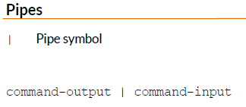

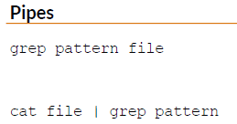

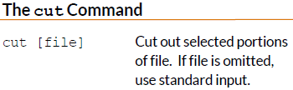

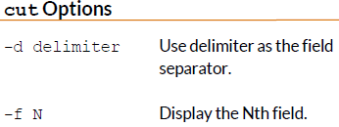

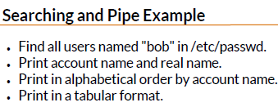

grep bob etc / passwd | cut -d: -f1,5 | sort | tr “:” “ ” | column -t

Transfering and copying files over the network
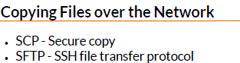

if you want to copy files from your local workstation to a linux server or between linux servers, you need to use SCP or SFTP.
SCP,SFTP are both extensions of secure shell protocol.
In order to use SCP,SFTP you need a client.
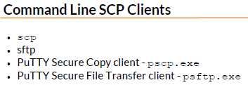

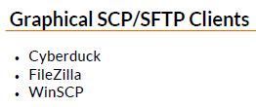

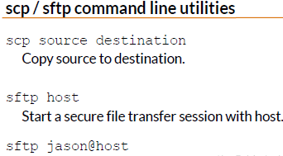

use sftp for a more interactive.
To use scp you need to know what files you want to transfer b4 initiating a command.
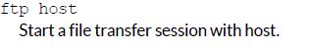

ftp isnt secure, you login credential are send in plain text over the network.
$Sftp linuxsvr
Connected to linuxsvr
sftp>pwd
/ home / jason
sftp>ls
sftp>lpwd
local working directory : / tmp / test
sftp>lls
z.txt
sftp> put z.txt
uploading z.txt to / home / jason
z.txt 100% 14
sftp> ls
rm z.txt
-----------------------
$scp z.txt linuxsvr:/tmp/
$ssh linuxsvr
$ls z.txt
$ scp z.txt adminuser@linuxsvr:/home/adminuser/
sftp> adminuser@linuxsvr
Filezilla is graphical interface.

Customizing the shell prompt
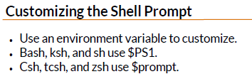

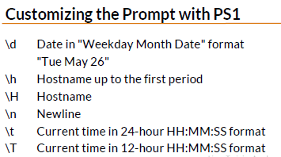

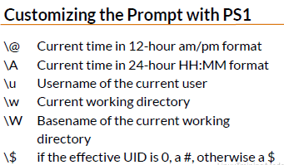

For more customization look at bash manpage.
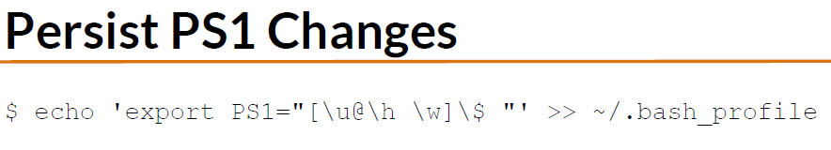
[adminuser@localhost ~] $
[\u @ \h \w] \$

Shell Aliases
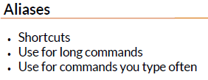

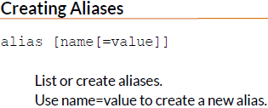

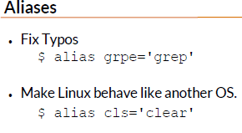

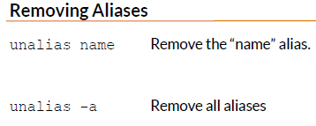

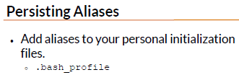

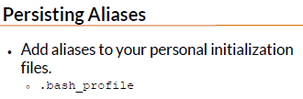

Day 5

Enviorment variables
Name/Value pairs
Can change how an application behaves.
An Example Enviorment Variable
Editor=nano
$printenv
$printenv HOME
$echo $home
Creating enviorment variables
export VAR=”value”

e.g:
export EDITOR=’VI’
export TZ=”US/Pacific”

Removing Enviorment Variables
unset VAR
unset TZ
Persisiting Enviorment Variables
$ cat ~/ .bash_profile
export TZ=”US/Central”

Processes and Job control
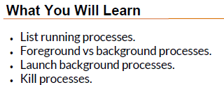



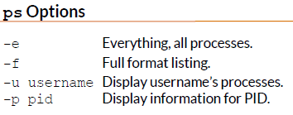
ps -fu jason

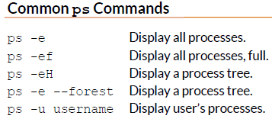

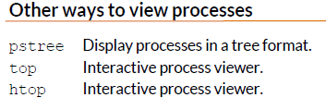
pstree good

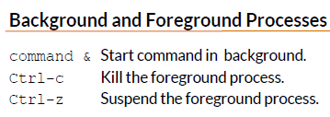
sudo -get update &
it will run in bg.
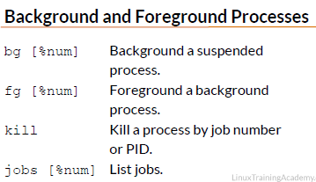
Process that is suspended isnt running in background

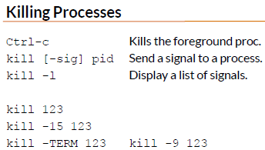
You can bg a specific job no, by preceding with % sign. If you don’t supply the %num, bg will operate on current job. Current job will be the last job that was stopped while it was in fg or the last job that was started in the bg.

if the process doesn’t terminate using the termination signal use
kill -9

$jobs
-Previous job
+Current job
Current job can be explicitly reffered as %% or %+ and previous job as %-.
$fg %2

Scheduling Repeated jobs with Cron
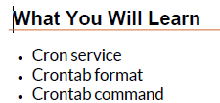

Cron job is used to automate process and do maintainence
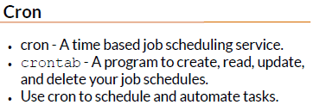

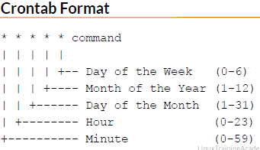

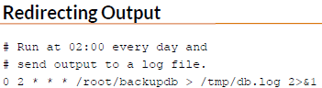

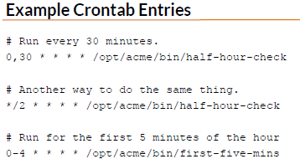

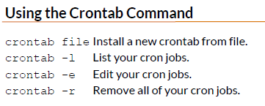

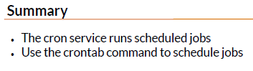

Switching users and Running command as others
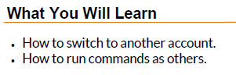

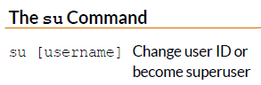

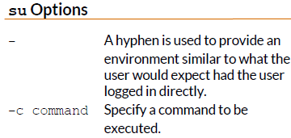
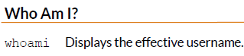

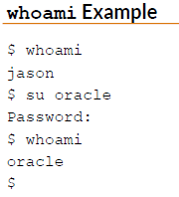
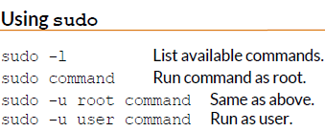

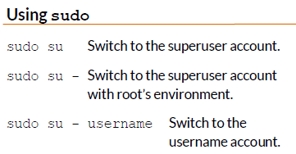

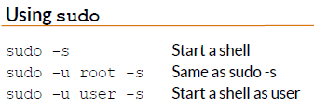

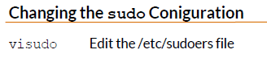

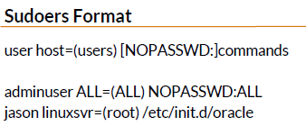

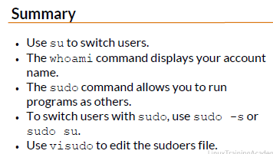

Shell history and tab Completion
- Shell history
- Exclamation Mark syntax
- AutoCompletion
Shell history
Executed Commands are added to the history.
Shell history can be displayed and recalled.
Shell history is stored in memory and on disk.
- ~/.bash_history
- ~/.history
- ~/.histfile
History command
history Display the shell history
HISTSIZE Controls the number of commands to retain in history
export HISTSIZE=1000 (defualt is 500)
! Syntax
!N Repeat command line number N
!! Repeat the previous command line
!String Repeat the most recent command starting with “string”
In addition to executing the entire command in history you can pull out part of the command.
!=!! <both same
! :N <Event> <Seperator> <Word>
:N Represent a word on the command line
0=command , 1= first argument,etc

for e.g
$head files.txt sortedfiles.txt notes.txt
$!! Runs the previous command
head files.txt sortedfiles.txt notes.txt
$ vi !:2
vi sortedfiles.txt
Even More !syntax
!^ represent the first argument !^ = !:1
!$ Represent the last argument
$head files.txt sortedfiles.txt notes.txt
!^=files.txt
!$=notes.txt
Searching Shell history
Ctrl -r Reverse shell history search
Enter Execute the command
Arrows Change the command
Ctrl-g Cancel the search
Tab autocompletion
- Commands
- Files,directories,path
- Enviorment Variables
- Username(~)

$!h
history
1.history
2.echo $HISTSIZE
3. history
$!2
echo $HISTSIZE
$echo !^ !L:2 kazim !L:0
$ Press Ctrl+r
‘ec’
it will give u a command
so press Ctrl+r to get next previous command

